2-3 Milestone One: Project Proposal

Aisha Washington
Southern New Hampshire University
CS-330-15560-M01 Comp Graphic and Visualization
Instructor: Omar Aaziz
May 17, 2026

2-3 Milestone One: Project Proposal
Selected 2D Scene
For my 3D scene, I chose a photo of a Candyland-themed children’s party center because it is colorful, playful, and full of simple shapes that can be recreated in OpenGL. The picture shows a glowing slide, a large ball pit, oversized balls, and bright cartoon decorations on the walls. I like this scene because it has a fun atmosphere and gives me a lot of options for building different objects. The shapes in the image are easy to break down into basic geometry, which makes the modeling process more manageable. Overall, this Candyland scene gives me a strong foundation to create a 3D environment that is both creative and achievable for this project.
Photo I chose:
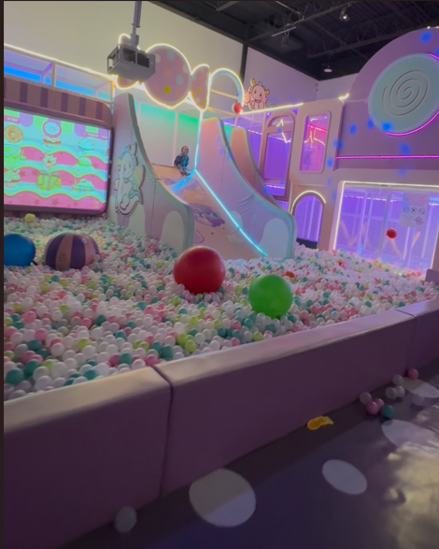
Objects Selected for 3D Replication
I decided to model four main objects from the Candyland scene: the slide, the ball pit, the large decorative balls, and the wall decorations. I chose these items because they each stand out visually and can be built using the basic shapes required for the assignment. The slide is especially important because it uses more than one shape, which meets the project requirement for a multi-shape object. The other objects help fill the space and make the scene look complete and lively. Together, these choices allow me to build a scene that is colorful, balanced, and realistic while still being simple enough to finish on time.
Breakdown of Objects Into Basic 3D Shapes
Slide
The slide will be created using planes for the flat surfaces and a tapered cylinder or prism for the support structure underneath. This object works well because it combines multiple shapes, which helps me practice building more complex models. It also gives me a chance to work with curves and angles, which are important skills in 3D graphics. The glowing edges in the photo can later be recreated using lighting techniques to make the slide stand out. Overall, the slide adds height, movement, and personality to the scene, making it one of the main features.
Ball Pit
The ball pit will be modeled using a plane for the base and many spheres to represent the balls. Even though the shapes are simple, the large number of spheres makes the ball pit look full and realistic. Creating the balls will help me practice repeating shapes and adjusting their size, color, and position. The ball pit also covers a big area of the scene, which helps ground the other objects and gives the environment structure. Its bright colors and playful look fit perfectly with the Candyland theme and help bring the scene to life.
Large Decorative Balls
The large decorative balls will be made using spheres, which are easy to model but still add a lot of visual interest. Their size makes them stand out, and their smooth surfaces will let me experiment with lighting and shading. These balls help break up the space and make the environment feel more dynamic and have fun. They also match the playful style of the Candyland theme and help tie the whole scene together. Including these balls adds color, shape variety, and a sense of scale to the final project.
Wall Decorations
The wall decorations will be created using extruded shapes, cones, and cylinders to match the cartoon-style designs in the photo. These decorations look more detailed, but they can still be built using basic geometry. Modeling them will help me practice combining shapes and adding depth to flat designs. They also help frame the scene and make the background more interesting and complete. Their bright colors and fun designs add personality to the environment and support the overall Candyland theme.
Ground Plane
The ground plane will serve as the floor of the Candyland play area and will anchor all the objects in the scene. This plane is important because it gives everything a surface to sit on and helps keep the layout organized. It also helps with lighting and shadows, which will make the final render look more realistic. The ground plane sets the scale for the rest of the objects and helps everything feel connected. Without it, the scene would not look grounded or complete.
Overall Scope and Feasibility
This Candyland scene is a great fit for the final project because it is creative, colorful, and still manageable to build. Each object can be made using basic shapes, which keeps the modeling process realistic for the time we have. The scene also gives me opportunities to use textures, lighting, shading, and camera controls later in the course. The bright colors and simple shapes will help the final project look polished and visually appealing. Overall, this scene gives me a strong foundation to build a fun and engaging 3D environment in OpenGL.

